موضوع تحقیق : چند سوال تاریخ : 29/08/1404
استاد راهنما : دکتر سجاد فرخی
گرد آورنده : علیرضا کاروی
- بخش ۱۰ فایل test3.m را بررسی کنید

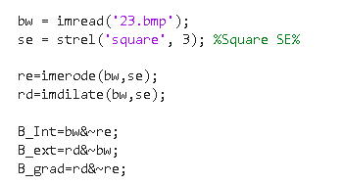
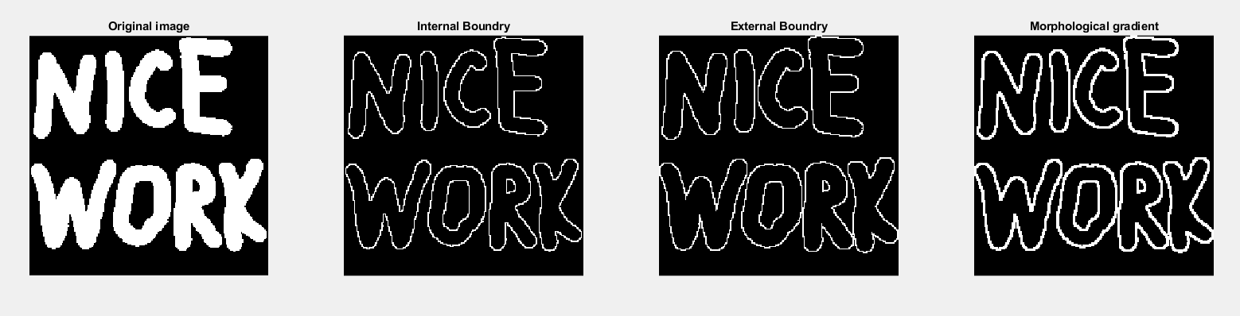
- …………………………………………………………………………………………………………………………………………………………………………………………………………………………………………………………………………………………………………………………………………………………………………………………………………………………………………………………………………………………………………………………………………………………………………………………………………………………………………………………………………………………………………………………………………………………………………………………………………………………………………………………………………………………………………………………………………………………………………………………………………………………………………………………………………………………………………………………………………………………………………………………………………………………………………………………………………………………………………………………………………………………………………………………………………………………………………………………………………………………………………………………………………………………………………………………………………………………………………………………………………………………………………………………………………………………………………………………………………………………………………………………………………………………………………………………………………………………………………………………………………………………………………………………………………………………………………………………………………………………………………………………………………………………………………………………………………………………………………………………………………………………………………………………………………………………………………………………………………………………………………………………………………………………………………………………………………………………………………………………………………………………………………………………………………………………………………………………………………………………………………………………………………

- تحقیق درباره opening و closing در morphology
……………………………………………………………………………………………………………………………………………………………………………………………………………………………………………………………………………………………………………………………………………………………………………………………………………………………………………………………………………………………………………………………………………………………………………………………………………………………………………………………………………………………………………………………………………………………………………………………………………………………………………………………………………………………………………………………………………………………………………………………………………………………………………………………………………………………………………………………………………………………………………………………………………………………………………………………………………………………………………………………………………………………………………………………………………………………………………………………………………………………………………………………………………………………………………………………………………………………………………………………………………………………………………………………………………………………………………………………………………………………………………………………………………………………………………………………………………………………………………………………………………………………………………………………………………………………………………………………………………………………………………………………………………………………………………………………………………………………………………………………………………………………………………………………………………………………………………………………………………………………………………………………………………………

